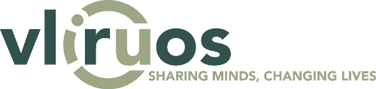

Theory of Change and methodological Guide – support document
For SI, TEAM Fully Fledged, ITP and IUC
Table of content
Theory of Change and methodological Guide – support document 1
Introduction to formulation guidelines 4
Modular approach 4
How to use this guide? 5
SDG principles 5
Leave no one behind 5
Interconnectedness 6
Multi-stakeholder partnerships 6
Transversal and priority themes 7
Gender 7
Environment 9
Module 1: Context 11
Context and problem analysis 11
Checklist to integrate the SDG principles in Module 1 12
Module 2: Project strategy (Impact statement and Theory of Change) 13
Impact statement (= the dream) 13
Developing a project strategy (Theory of Change) 14
Checklist to integrate the SDG principles in Module 2 17
Module 3: Organisation 19
Who is involved? 19
How is the project structured / organised? 19
Checklist to integrate the SDG principles in Module 3 20
Module 4: Stakeholders and coherence 21
Stakeholder identification 21
Stakeholder analysis 23
Strategies for stakeholder engagement and uptake 24
Coherence…………………………………………………………………………………………………….28
Checklist to integrate the SDG principles in Module 4 28
Module 5: Planning & budgeting 29
Checklist to integrate the SDG principles in Module 5 29
Module 6: Risks 30
Module 7: Monitoring & reporting 31
Use & reporting of indicators 32
Checklist to integrate the SDG principles in Module 7 33
Module 8: Learning & steering 34
Formulating lessons learned and learning from experience 34
Checklist to integrate the SDG principles in Module 8 34

Annex 1…………………………………………………………………………………………………………..35

Introduction to formulation guidelines
This basic guide translates the principles of the VLIR-UOS Monitoring and Evaluation (M&E) policy into a basic guide for the formulation of VLIR-UOS supported projects. The formulation of a project is much more than writing a document. It is a participative process in which partners co-create a project based on a shared vision of change, and a shared understanding of the current situation.
This project formulation guide provides practical information on the different modules that need to be developed to arrive at a qualitative proposal. The development of these interrelated modules is explained in a stepwise process.
This document is for all project types that work together with VLIR-UOS partner countries and treats all they have in common (SI/ TEAM/ ITP/ IUC). Any specific aspects per project type are explained in the corresponding project call.

Modular approach
The guide consists of 8 Modules, following the format of the call.

The added value is that the modules are linked to each other, for example based on the context analysis in Module 1 a theory of change is formulated, alignment is sought with the generic VLIR-UOS Theory of Change and the standard project domains (of intermediate change) are selected. During formulation, it is recommended to move back and forth between modules, it is not necessary to strictly follow the sequential order from 1 to 8.

How to use this guide?
The guide is intended to be used as a reference guide in which the brief summaries (blue boxes) at the beginning of every chapter enable the reader to have a quick overview of the document (and the formulation process). At the end of every module, a set of guiding questions is provided on how to integrate the SDG principles (orange boxes). For details of a particular call, the call document with additional requirements / selection criteria should be consulted when preparing the submission.

The symbols below are used to highlight references to a particular module of the guide, the SDG principles and gender.

Legend
refers to linkages between the modules
Leave No One Behind principle (LNOB)
Interconnectedness & indivisibility principle (INT)
Multi-stakeholder partnerships (MSP)
Gender

SDG principles
All VLIR-UOS supported projects are expected to be SDG-proof. This means that the SDG principles ‘leave no one behind, interconnectedness and multi-stakeholder partnerships’ should be integrated during the formulation process, implementation and monitoring, evaluation and learning phase. These principles underpin the United Nation’s 2030 Agenda for Sustainable Development and its 17 Sustainable Development Goals (SDGs).

Leave no one behind
The principle of leaving no one behind (LNOB) is defined as a three-part imperative: to end absolute poverty in all its forms, to stop group-based discrimination that results in unequal outcomes for disadvantaged populations, and to take action to help the furthest behind. This means that VLIR-UOS supported projects should mainstream the LNOB-principle throughout the project cycle to ensure that vulnerable and marginalised populations are included in and benefit from higher education partnerships for development. It is important to acknowledge the heterogeneity in vulnerable groups. There are inequalities between groups (inter-group inequalities: differences between ethnic groups, regions, women and men) and inequalities within a group (inter-individual inequalities: within a certain region some people are more left behind than others, within a group of women some are more vulnerable than others). Being left behind is also multi-dimensional (e.g., it can happen that you are economically left behind but not politically) and context-dependent (e.g., the groups left behind in Indonesia are not necessarily the same as in Kenya).

Having a clear understanding of LNOB is an important first step. Exclusion, discrimination and inequality is a structural problem. It does not disappear spontaneously, because it is grounded in deeply rooted inequality mechanisms and unbalanced power relations.
The approach to integrate LNOB is two-fold. On the one side, there is the mainstreaming approach, where the project identifies groups left behind or at risk of being left behind, understand the drivers of exclusion (e.g. age, disability, ethnicity, sex & gender, …) and makes a thorough examination of how an intervention affects the most excluded. On the other side, specific projects can be developed, where interventions are designed, specifically targeting the groups left behind on the basis of their specific needs and are taking a long-term view of the transformative change. Of course, a combination of both approaches (twin-track approach) is possible as well.
Projects are encouraged and facilitated to develop an uptake strategy that takes into account the views and needs of vulnerable groups to ensure that solutions, practices and policies with high development relevance are accessible and beneficial to these groups. More details are provided in the modules with guiding questions for integrating the principle.

Interconnectedness
The principle of interconnectedness refers to the interlinkages and indivisible nature of the SDGs.
During project formulation, it is important to look at a problem from an interconnected perspective. As an essential first step in considering the complexity of societal change, all VLIR-UOS supported projects develop a holistic context analysis (Module 1) which moves beyond sectoral and disciplinary borders. This context analysis should explore the interlinkages between different SDGs to identify positive and negative trade-offs and side-effects (e.g., agriculture is linked to climate change, health, gender roles, biodiversity, etc.). This also includes attention for transversal themes gender equality and environmental sustainability (cf. transversal themes).

Creating and sharing knowledge across disciplines is essential to make societal impact, inform systemic change and accelerate progress towards SDGs. Therefore, projects are encouraged to form inter-disciplinary, multi-institutional partnerships (MIPs) to build connections between departments, academic disciplines, universities, regions and even non-academic stakeholders in the case of transdisciplinary research. During the partnering stage, it is useful to reflect on what different types of academic disciplines can be connected in interdisciplinary teams to tackle a problem. The stakeholder analysis should reflect on the potential interlinkages at different levels (academic and non-academic actors in civil society, public, private sectors) and inform the development of strategies for active engagement with other sectors and domains. For example, interconnectedness can be stimulated through stakeholder workshops, knowledge sharing platforms or multi-stakeholder partnerships (see below).

Coherence, Multi-institutional and Multi-stakeholder partnerships
The complexity, scale, and interconnectedness of the current societal challenges that the SDG framework is seeking to address, requires a concerted effort or collaboration by a wide variety of actors. This need for concertation/collaboration is translated to 3 potential approaches. Proposals are invited to explore these.
- Coherence: The Agenda 2030 urges actions to be coherent with the actions and networks of other actors and/or other HES4SD initiatives. An analysis of complementary actions by academic and non-academic actors is essential for each partnership (to ensure coherence). VLIR-UOS wants to facilitate coherence and connections between different actors and projects present in each country and across borders. With these objectives in mind, Country Reference Framework (CRF) documents support teams of academics when identifying and formulating project proposals.
- Multi-Institutional Partnership (MIP): This concerns a structural collaboration between several higher education institutions at Flemish/Belgian (including ITM) and/or partner level within the framework of a project, with the aim of obtaining better results by pooling available expertise. The different institutions take up a meaningful and important role in the project. In fact, the Flemish higher education institutions have recently created a platform through their “associatieve projecten” that are dedicatedly fostering these types of cooperation.
- Multi-stakeholder Partnership (MSP): this concerns a structural collaboration with at least 1 non-academic actor (= multi-stakeholder; civil society, private sector, governmental actors, etc.) in which this actor plays an active role in the project implementation, working towards a concrete common goal. The roles and responsibilities of each stakeholder are formalized. VLIR-UOS acknowledged that collaboration has its challenges, all the more if the different stakeholders span the boundaries of business, government, civil society and science. Therefor it should be planned and designed carefully through a stakeholder analysis with an uptake-oriented stakeholder management strategy (module 4). Also, the levels of commitment and expectations should be monitored and managed.

The engagement of a diverse range of stakeholders in interventions is promoted, especially those left behind (local grassroots movements, women’s associations, youth networks, trade unions, business, government, …). The scope of involving a wide variety of stakeholders will depend on the context, resources, ambition and capabilities of the project. Crucial is that the most relevant stakeholders are consulted from the start of the project, to identify their needs and influence, until the uptake of results, to make sure the project has societal impact.

Transversal and priority themes

Gender
VLIR-UOS is committed to achieving more gender equity and equality in the VLIR-UOS partner countries, including Belgium. VLIR-UOS gender policy follows a threefold strategy. Firstly, projects should fix the numbers and monitor sex-disaggregated data. Secondly, (long-term) projects should fix the organisation and ensure adequate structures, decision-making mechanisms and policies are in place to promote gender equality. Thirdly, projects should fix the content and improve knowledge on gender. There are two pathways of integrating gender in VLIR-UOS portfolio, through targeting stand-alone projects with a specific focus on gender or through the mainstreaming of gender in all projects (e.g. all projects have an outcome / activities related to gender) or the twin-track approach.
Why gender matters?
Sustainable and inclusive development cannot be achieved if women and girls, who constitute half of the population, do not have equal rights and prospects. Furthermore, insufficient use of human capital within the higher education sector has a harmful impact on the development of higher education institutions, as it decreases efficiency and excellence by missing out on women’s involvement at all academic levels. More in general, ending all forms of discrimination against women and girls is also crucial to accelerating sustainable development. It has been proven time and again, that empowering women and girls has a multiplier effect, and stimulates economic growth and development.

Fixing the numbers: focuses on increasing women’s (or men’s) participation to have a balance
- Does the project ensure gender balanced representation in the team? (cfr. VLIR-UOS policy: 40-60% representation of underrepresented group)
- Does the project ensure gender balanced participation and representativeness at project activities? (e.g., by providing day care during training)
- Does the project identify cultural/religious/legal restrictions that would not allow women or men to participate in project activities (e.g., identify the reasons making it difficult for young female academics to work outside office hours)?
Fixing the organisation: focuses on the institutional structure and how gender is (implicitly) understood
- Does the project create structural and organisational changes in the gender balance of the higher education institution (e.g., developing a strategy and action plans on gender, appointing a gender focal point committee / work group / task force)?
- Does the institution have a gender policy (incl. a transparent policy for scholarship selection) and action plan?
- Does the project include a member with gender expertise? Does the project incorporate mechanisms to ensure gender balanced participation in decision-making processes?
- Does the project engage with women’s groups, associations, NGOs as project counterparts and/or as gender advisors? (e.g., consulting a microfinancing institution for women on fertiliser use)
Fixing the content: focuses on integrating gender analysis (what is the effect of gender on the intervention, how should the intervention be designed to deal with this effect, and what is the effect of the intervention on gender)
- Does the project consider the way in which the situations/needs/challenges of men and women differ? (= gender analysis) (e.g., investigating the role of women in the environmental management practices of indigenous communities)
- Does the project take different gender roles and divisions of labour between men and women into account? (= gender sensitivity) (e.g., considering gender differences in research on unemployment)
- Does the project focus on changing gender roles and divisions of labour between men and women? (= gender transformative approach) (e.g., working on awareness raising with girls for HIV/AIDS prevention)
- Does the project integrate sex and gender analysis into research? (e.g., including perception differences between men and women about ecosystem services as confounding factor in a research). Are the team members trained or will they receive training on gender and diversity?
- Does the project develop an uptake strategy that considers the views and needs of disadvantaged groups to ensure that solutions, practices, and policies with high development relevance are accessible and taken up by disadvantaged groups?

Environment
VLIR-UOS strives to ensure the protection of planetary boundaries, highly valuing environmental sustainability. VLIR-UOS therefore urges projects to integrate the transversal theme of environment throughout all phases of project cycle management, starting with the project proposal. Environment can be integrated on two levels: within the project management (e.g., CO₂ compensation, waste reduction, sustainable food consumption at events, …) and in the project content (as an objective or intermediary result or as environmental sensitiveness). We take into account a reciprocal relationship between projects and the environment, paying attention to the (negative/positive) effects of the project on the environment as well as the (negative/positive) effects of the environment on the project. VLIR-UOS projects are asked to analyse these mutual effects and to propose measures/actions which strengthen positive effects and/or mitigate negative effects. Throughout this process, projects should be guided by the ‘do no harm’ principle as a bare minimum to prevent, reduce and control the risk of environmental harm. Following the principle of interconnectedness, interlinkages between environmental and socio-economic factors should be taken into account and attention should be paid to potential trade-offs.

VLIR-UOS projects are invited to use the guiding questions underneath.

General
What is the environmental context of the project? What are the main environmental issues? What is the relationship between the environmental and socio-economic context? (Module 1)

Is the project’s main objective in line with the ‘do no harm’ principle, striving to prevent the risk of environmental harm and contributing to conservation and protection of the environment?
Effects of the project on the environment
What are the possible (negative/positive) effects of the project on the environment? (Module 2)
These possible (negative/positive) effects could be related to the project management (e.g., CO2 emissions due to international travel) as well as at to the project content (e.g., increase in chemical waste due to the installation of a new laboratory).

How do you estimate the degree of impact (low/average, high, positive/negative) of the project on these environmental factors?

What actions/measures will you undertake to strengthen positive effects and/or mitigate negative effects of the project on these environmental factors?
Effects of the environment on the project
What are the possible (negative/positive) effects of the environment on the project? Which risks related to environmental factors might have an effect on the realisation of the project? (Module 6)

These possible (negative/positive) effects could be related to the project management (e.g., deregulated seasonal rains have an impact on the project planning) as well as at to the project content (e.g., erosion decreases soil fertility). These could be effects on e.g., the implementation schedule, sustainability of the project, quality of the project, results of the project, etc.

What actions/measures will you undertake to strengthen positive effects and/or mitigate negative effects of environmental factors on the project? These actions/measures can be related to the project management as well as the project content. The mutual relationship and potential trade-offs between environmental factors and socio-economic characteristics should be taken into account.

Module 1: Context
ESSENCE
This aspect describes the context and justifies the importance of the project. It delimits the scope, contextualizes the reasons and describes why the project is needed (i.e., the problems being faced). The objective is to develop a broad – and shared – understanding of the system in which the desired change is needed.
KEY QUESTIONS
Sustainable development context:
- Scope & identification: Why is the project needed? What are key societal/developmental challenges in the region? Who is being left behind, from what and to what degree?
- Causes: What are the underlying causes / factors and actors shaping the problem?
- Interlinkages: How are sustainable development issues / problems linked to each other?
Partner institutional context:
- What are the key strengths and weaknesses of the partner institution / unit / department?
- What would be the added value of the project for the local institution/local team? Any previous experience between the project partners?
Individual and organisational capacity building context (ITP):
- What are the capacity constraints, at the level of the trainee (individual), as well as at the level of the professional environment of the trainee?
- What would be the added value of the project for the trainee as well as for the professional environment of the trainee?

Every project takes place in a context that determines the conditions and the opportunities for a successful project. That is why every project needs to have a good understanding of the context in order to make informed strategic choices when formulating the project, increasing the chances of success. This context analysis includes a thorough analysis of the sustainable development problem(s) the project wants to tackle and the added value for the local partner institution.

Context and problem analysis

Sustainable development context
A problem analysis identifies the challenges of an existing situation and analyses the ‘cause and effect’ relationships between the identified problems. These ‘problems’ occur in a context which is shaped by various actors and factors (e.g., historical, social, political, economic, cultural, ecological, geographical factors). The problem analysis involves three main steps:
- Definition of the framework and subject of analysis and identification of the major problems faced by target groups and beneficiaries (scope & identification);
- Analysis of the causes of the problem (Why is it a problem?);
- Interlinkages and effects in the broader context in which these problems occur.
During project formulation, it is important to reflect on who is at risk, from what, why and by whom in the context you want to work. The context analysis should delve deeper into the factors and actors that make certain people vulnerable. These factors can include discrimination, geography, vulnerability to shocks, governance, socio-economic status.
The identified problems also need to be framed within United Nation’s Agenda 2030 and the 17 Sustainable Development Goals (SDGs). During the context analysis, it is desirable to start reflecting on how the problems are interconnected, taking a holistic approach and acknowledging the complexity and global nature of the problems under consideration.

The targets linked to particular SDGs will come back in other modules when specifying the desired changes (Module 2).

Checklist to integrate the SDG principles in Module 1
Leaving No One Behind | - Have you identified which groups are (at risk of being) left behind within the intervention area (country, region) and from what they are excluded?  - Have you analysed why they are left behind (considering intersecting factors / underlying causes)?  - Have you formulated clear definitions or criteria for poverty, marginalization, exclusion, …?  - Have you conducted a gender analysis which examines the differences in women’s and men’s needs, roles and responsibilities, daily routines and activities, and access to and control over resources, services and decision-making, including those that lead to social and economic inequalities?
Interconnectedness & indivisibility | - Have you gained a solid understanding of the important interlinkages in the system in which you are working?  - How are these issues linked? What are important co-benefits and trade-offs (e.g., what is the relationship between the main environmental and the main social, economic and institutional issues of the place of the intervention? How do the main environmental factors influence the socio-economic situation of the intervention area, and how does the socio-economic situation impact the environment?)
Multi- institutional (MIPs) and Multi-stakeholder partnerships (MSPs) 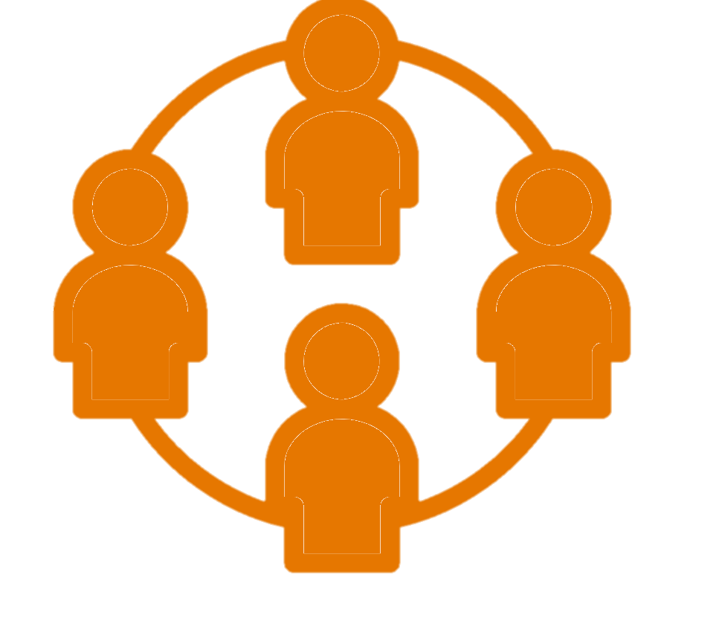 | - Do you have a solid understanding of the relevant actors and their relationships in the system in which you are working?  - Is the context-analysis co-created by the relevant (local) actors and does it include their perspectives?

Module 2: Project strategy (Impact statement and Theory of Change)
ESSENCE
Envision the desired long-term change (dream) to which the project wants to contribute. Describe an impact-oriented strategy with concrete activities and deliverables in the selected project change domains.
KEY QUESTIONS
Describe your project strategy (Theory of Change) in 3 key questions. While these questions echo the key questions in Theory of Change (ToC) thinking process, a fully-fledged ToC is not requested. This ToC should reflect the alignment of your project with the general VLIR-UOS ToC, and the 3 SDG principles. Explain your project following the key questions below.
Envision the dream (Why?):
What is the long-term desired change / dream to which the project wishes to contribute and for whom? (= impact in line with Agenda 2030). Elaborate in a narrative text but start from a simple impact statement.
What do you want to achieve with your project? (STEP 1 and STEP 2):
- What are the key areas where change (check standard VLIR-UOS outcomes a VLIR-UOS project can realistically influence, and align with these) is needed to contribute to the desired change / dream?
- Convincingly explain how the envisaged changes align with the VLIR-UOS outcomes.
How do you want to do it? (STEP 3): analyse the areas of change and reflect on the different underlying intermediate changes that need to occur and will be worked on through the overall project strategy by looking backwards from the long-term desired change (impact level) & prioritised change areas (outcome level); How can the project influence these envisaged change processes?
Explain how you will do it:
- Describe your operational and methodological approaches,
- Identify key deliverables and activities (in line with the project’s operational plan).
- In the operational plan, activities are to be organized according to the six standard VLIR-UOS project domains giving particular attention for the standard domain dissemination/uptake strategy. How to realise impact outside of the university? How will the project create the conditions for the effective uptake of new knowledge, applications and services?
- How can the project integrate gender? Explain the priorities in terms of integration of gender in the project strategy by reflecting on the actual gender situation and the potential impact of the project strategy.
- How can the project integrate environment? Explain the potential influence of the project on the environment and explain how the project will integrate environmental priorities in its strategy.

Impact statement (= the dream)
The first step is to concretise how your project will contribute to sustainable and equitable development. The relevant SDGs (one main and one secondary) should also be specified in the application.

This first step builds further or runs in parallel with the context analysis and allows to brainstorm and envision what the dream of the proposed project is, if applicable in line with local priorities and the local institutional context. The desired long-term change should be challenging and ambitious, but not impossible to achieve (reachable in 15 years’ time; the project only contributes). Identify if and how you can ensure synergy and complementarity with other actors with other (Belgian) actors as much as possible in the light of synergy and complementarity.
- Who should benefit from the desired change / dream? Will the dream impact differently on certain groups (gender, age, ethnicity, etc.)?
- What will have changed?
- Where will the change happen?
- How this change can be realised forms part of the different pathways “theorizing” the change. Such a theory of change will be further developed throughout this module and translated into a project strategy with concrete deliverables / activities (=theory of action, for VLIR-UOS project translated into 6 standard (project) domains of intermediate change).

A dialogue about existing understandings of how change can happen
The people and organisations involved may have different views on what the desired change is, why it is desired and how the change can occur. If these different views are not shared, misunderstandings are often happening. A good formulation process is participative and foresees space for collective reflection, discussion, etc. Visualisation is often considered as helpful to structure the discussions and can help in getting all participants on the same page.

Developing a project strategy (Theory of Change)
A Theory of Change serves as a compass for the project strategy and invites to critically reflect upon the most appropriate interventions and their interaction with processes of change. It visually and narratively describes the envisaged change process: how pathways of change can lead to the realisation of the dream, which actors play a role in the change process and how they interact, with assumptions to go from one change to the other.
Step 1 – Identify areas of change to realise the dream (Why?)
In order for the dream / desired change to happen, changes need to happen in different areas simultaneously. After having analysed the actors and factors in a particular context (Module 1), the stakeholders can start to reflect on the dream and identify the areas where important changes need to be made in order to realise the dream.

Step 2 – Prioritise the key areas of change to which the project can realistically influence in order to contribute towards the ‘dream’ (What?)
The second step is to decide on the strategic priorities (what area(s) will the project work on) without forgetting the complexity of the process towards the long-term desired change.
What do you want to achieve with your project by the end of the project? This needs to refer to the Changes you want to achieve/observe by the end of the project. Convincingly explain how these align with the VLIR-UOS outcomes (cf. call document).
This reflection is crucial and acknowledges that, although the project cannot work on everything (and choices have to be made), it still is a part of a bigger reality. It will further in the formulation process determine the project strategy and the levels of the results framework. It should be realistic and feasible to contribute to the desired change by working on the prioritised area(s) for change. A project cannot work on all problems. Therefore, it is recommended to limit the number of area(s) of change based on the available resources, capabilities, ambitions of the project. Moreover, as VLIR-UOS supports partnerships between universities and university colleges in Flanders and partner countries, a number of areas of change will automatically be excluded (For example: a VLIR-UOS project will never finance road construction). The different possible strategies and areas of change should be examined and the most appropriate areas of change for the project are to be selected based on criteria such as:
- Available know-how, capacities and interest of the stakeholders
- Complementarity with other actions
- Priority
- Expected value for money
- Expected effect and expected leverage in terms of (gender) equity (Does the strategy respect the principles of inclusive development?)
- Environmental relevance (Does the strategy respect the principles of sustainable development?)

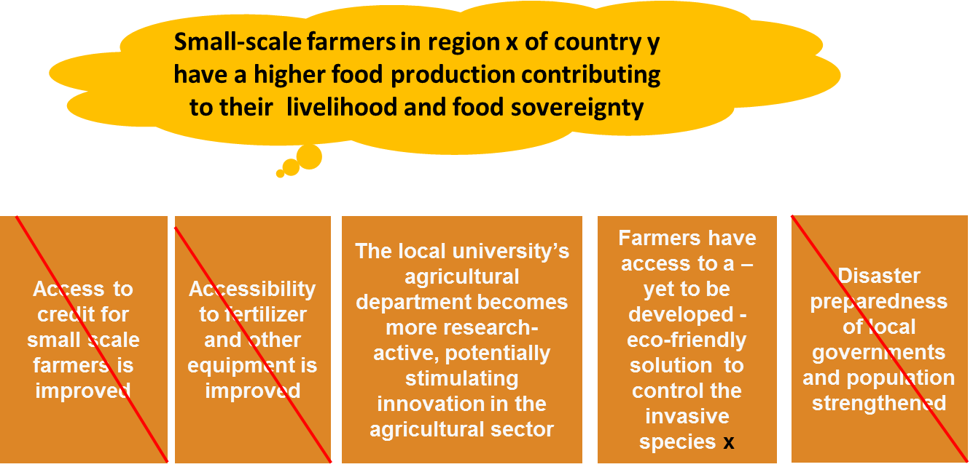
Reflect on the challenges for the sustainability of the project results after VLIR-UOS funding. Some examples are: capacity retention, continuation of improved research activities, maintenance of equipment, post-training activities, alumni-network, …

Figure 1: Prioritising change areas into project objectives (outcome statement)
Point of attention: Make sure to highlight the project priorities in terms of the 3 SDG principles as presented by VLIR-UOS:
- Interconnectedness with due attention for the integration of gender and environment
- Coherence, multi-institutional partnerships and multi-stakeholder partnerships
- Leave No One Behind (LNOB; with due attention for the integration of gender equality)

Step 3 – Operational and methodological approaches
The third step elaborates the operational and methodological approaches: How do you want to do it? Key deliverables and activities are identified and the activities are organized along the six standard VLIR-UOS project domains. It is not obligatory to realize changes in all six domains. The project can choose the domains it wants to address and corresponding deliverables of your project need to be selected.
Domain | General description  (VLIR-UOS ToC)
Research  programmes and methods | Improved (interdisciplinary) methodologies and strengthened quality and relevance of research to allow for better knowledge management and high-quality research results serving societal needs
Education programmes and methods | Improved, innovative and inclusive teaching methods, didactics, and digital approaches. Improved curriculum content to support knowledge co-creation and equip students with the necessary skills and knowledge ensuring their employability after graduation and ability to tackle global challenges from a holistic, interdisciplinary perspective
Outreach and policy support | Enhanced interaction with relevant public, private and academic stakeholders to share knowledge, create the conditions for uptake and provide policy advice/support
Systems,  policies, and  infrastructure | Better management, information systems, educational and research policies to improve functioning of HE&SIs, including policies on gender and diversity, research integrity and uptake. Improved equipment, laboratories and offices for education and research
People | Students, alumni, staff, researchers are trained/sensitised in a supportive learning environment to strengthen their knowledge, skills & attitudes in diverse domains (e.g., leadership, global citizenship).
Networks and partnerships | Strengthened interactions within reciprocal partnerships and engagements at local, regional and global levels between HE&SIs, researchers, staff, students and other stakeholders in society (public actors, private actors, other civil society organisations (CSOs), communities, etc.) for sustainable development

Step 4: A final check
Go through your Theory of Change again and ask yourself if the flow of subsequent steps is logical. Are there any steps missing? Is the overall ToC coherent? What else might each step lead to? Will the different changes be sufficient? Did we sufficiently take into account stakeholders’ attitudes and interests? What contextual factors are important?
The final step is the identification of risks and assumptions, which can be integrated in the Theory of Change narrative since the risk module is not included, except for TEAM-fully fledged and IUC proposals.

Managing the change – special attention for uptake
A clear vision needs to exist about how the ‘change’ of a project will be managed. This is important to think about during the development of the Theory of Change, as it is often assumed that activities, simple deliverables or ‘training’ personnel and/or stakeholders is sufficient to create genuine change, while this is rarely the case.
What rarely leads to successful uptake?
Assuming new knowledge will result in uptake by publishing in journals or by organising a one-off dissemination activity at the end of a project or programme.
Assuming training a number of persons in a particular field (e.g., lab techniques, e-learning, etc.) will be sufficient to lead to an effective use of this new knowledge/skills in university’s operations.

The projects also aim to have an impact outside the academic context (cf. the VLIR-UOS motto “Sharing Minds, Changing Lives”), not only after the intervention but also during the intervention via stakeholder involvement and by creating the conditions for uptake from the start. Societal impact requires uptake of new knowledge created by projects, applications, products, services, etc. This ‘uptake’ does not happen automatically. It is important that projects develop the capacities and strategies to create the conditions for this uptake. Developing an uptake strategy, allows projects to make explicit how one thinks a project can go from producing knowledge, applications or services, to making an actual societal impact.
In Module 4, Stakeholder management refers to the general management of the interactions with the most important stakeholders of a project (external to the project team), contributing to the realisation of the project outcomes and impact (e.g., the end-users of the project results).

Checklist to integrate the SDG principles in Module 2
Leaving No One  Behind | Targeting approach:  - Does your theory of change clearly outline how your intervention expects to contribute to (sustained) positive change for the target groups?  - Have you reflected on whether design and implementation reinforce existing exclusion mechanisms, or disadvantages vulnerable groups within and/or beyond your target groups?  Mainstreaming approach:  - Does your theory of change outline how your intervention expects to indirectly benefit (important) left behind groups?  - Have you adapted strategies or identified remedial action (by yourself, by partners, or by others) to address/mitigate any exclusion effects?  - Does the project create structural and organisational changes in the gender balance of the higher education institution (e.g., strategy and action plans on gender, appointing a focal point…)?
Interconnectedness & indivisibility | - Have you identified important positive and negative links between your intervention area and other SDGs (or targets)?  - Have you taken important (positive and negative) links into account in the design and implementation of your theory of change (e.g., in objectives, strategies)?  - What environmental elements need to be taken into account to achieve change (e.g., climate change affecting harvesting seasons)?  - Will the change process have a positive or negative impact on the environment (e.g., the introduction of soil conservation practices)? This can be on a direct (e.g., the introduction of exotic species) or indirect level (e.g., access to resource-efficient technologies).
Multi-institutional partnerships (MIPs) and Multi-stakeholder partnerships (MSPs) | - Potential to establish a MIP or a MSP or not? Does a MIP or MSP offer opportunities to better (e.g., more systemically or sustainably) address the (complex) challenge(s) that your programme focuses on?  - Have you identified valuable partners and forms of collaboration?  - Have you identified an added value of your participation in the MSP?

Module 3: Organisation
ESSENCE
Describe who is (internally) involved in the implementation of the project – and how.
Clarify the structure of the organisation and assigned roles and responsibilities of individuals working on the project.
KEY QUESTIONS
- Who is internally involved in the execution of the project?
- What are the assigned roles and responsibilities of individuals working on the project?
- How is the project structured / organised?

The implementation of a project depends on several people to make decisions, to provide information, to carry out activities and to monitor and report throughout the project. It is important to clarify and agree upon the structure of the project organisation and task division before the start of the project.

Who is involved?
Individuals who are involved in the execution of the project include: the partner institution / Flemish promoter, local / Flemish team members, other persons / staff involved in the project implementation (such as ICOS, local administrative and financial staff, etc.). General information (name, e-mail address, position / function, institution, CV link, etc.) should be provided in the excel sheet.

How is the project structured / organised?
Short description of the project organisational structure and distribution of responsibilities with attention for balanced partnership structures and multi-institutional partnerships.
Explain how the project will assure a continuous link with and involvement of the partner university (if applicable).
In case multiple partners are involved at Flemish or partner level, the roles of each partner in the implementation and management of the project need to be explained. How will the tasks be divided among the involved partners (Flemish and/or local) in a balanced way?
VLIR-UOS also seeks to stimulate multi-institutional partnerships between the Flemish universities and university colleges. The vision on how the project will create broad support of / collaborations between Flemish universities and university colleges should be detailed in the proposal. For example, expertise available at a particular university and university college can be combined to enrich the project proposal.
Take into account that for ITPs the participants of the training are an important group. The selection criteria for this target group must be described in the proposal, as well as the procedure for selection. This goes hand in hand with a targeted communication and recruitment policy (e.g., focus on specific region or country or specific background (LNOB)) and gender.

Checklist to integrate the SDG principles in Module 3
Leaving No One  Behind | It is important to keep an eye on the diversity of a team.  - Does your organisational set-up ensure the participation of left behind groups in decision-making?  - Are left behind groups involved in the decision-making processes (e.g., through an advisory board)?
- Does the project ensure gender balanced representation in the team? (cfr. VLIR-UOS policy: 40-60% representation of both sexes)
- Does your project incorporate mechanisms to ensure gender-balanced participation in decision-making processes?
- Does the project team include a member with gender expertise, a gender focal point / task force / working group?
Interconnectedness & indivisibility | - Interdisciplinary approach?  Ideally teams are multi/inter/transdisciplinary (=approaching a particular problem from different (scientific) disciplines).
Multi-institutional (MIPs) and multi-stakeholder partnerships (MSPs) | - Did you identify opportunities to collaborate with other institutions and/or other actors, such as civil society, public and private stakeholders, during project design and implementation?  - Have you reflected on the optimal division of roles and responsibilities in the partnership?  - Can all partners participate in decision-making when they want to? Do they have voice?

Module 4: Stakeholders and coherence
ESSENCE
Identify and analyse the key stakeholders that will be involved in or will benefit from the project. Identify how the project will engage with these stakeholders. These include both internal (inside HEI, but external to project team) and external (outside HEI) stakeholders, and direct and indirect beneficiaries.
KEY QUESTIONS
- Who are the key stakeholders? What is their role in the current context?
- What is their potential role, interest and influence in the project?
- How will the project involve / engage with stakeholder? (e.g. community-based research, participatory research methods, multi-stakeholder partnership, value chain / food system approach,… )
- How will the project ensure synergy & complementarity with Belgian actors and other VLIR-UOS projects? (check out the VLIR-UOS Country Reference Frameworks)
- How will the project create the conditions for uptake of results?
- Add how the project will facilitate the collaboration between multiple stakeholders and, if applicable, turn it into an effective multi-stakeholder partnership?

Stakeholder identification
The identification of project stakeholders should focus on the key players. Defining and prioritising who are the key players, will help you formulate approaches to engage with them and/or involve them in the project (see engagement strategy later in this module).
Project stakeholders are groups of people or organisations who have an interest (a stake) in the (proposed) project and hence can (positively or negatively) influence or contribute to the project.
During project formulation, you need to be pragmatic in the choice of target groups and prioritise what strategies are possible to involve/engage with them. The stakeholders include both internal (but external to project team like e.g., trainees, co-organisers of a training) and external (outside the HEI) stakeholders, such as employers of the trainees, local communities, private sector, (local) government, civil society organisations, NGOs, etc. Stakehol-ders can consist of direct beneficiaries (the group that will be benefiting from the services of the project at the outcome level) or potential indirect beneficiaries (those who will be benefiting from the project in the long run, e.g., farmers, local governments, etc. (impact level)) and any other actor with a stake in the project. When identifying stakeholders, general terms should be avoided (e.g., not “government” but more specific government level and department). The stakeholders may be users of the research and those who can help or hamper the research uptake strategy (e.g., extension office).
Identifying stakeholders before the start of a project can be challenging, but this step should not remain static at one point in time. Stakeholder engagement is a dynamic process that evolves during project implementation. Therefore, it is recommended to regularly update the stakeholder analysis in annual reporting to keep track of stakeholder activities and communication (e.g., which stakeholder is no longer actively participating, which new stakeholders expressed interest, how are relationships and roles changing along the process, what positive and negative elements need to be dealt with, etc.).
The stakeholder identification and analysis need to take into account the potential differences for men and women. It should identify who is left behind in the sector/context the project is working. It is not always needed to work with the poorest of the poor. How far you want to go depends on the context and the ambition of the project.
The following aspects are important to describe the characteristics of the project’s stakeholders:
1. Are they internal or external stakeholders?
Internal stakeholders are part of your institution and might influence your project or have a stake in it. They are however not part of the project team (Project team is part of Module 3).  For example: potential trainees who will follow a training that you aim to develop as part of your project or the management board of the university that is responsible for policies that affect the execution of your project. | External stakeholders are not part of your institution but have an interest in or are impacted by your project.  For example: employers of trainees, farmers from nearby communities, policy makers, patient representative groups, local NGOs, etc.

2. From which sector are they?
Stakeholders can ‘be part of’ different kind of sectors: civil society, public or private sector, other academic / research institutions or VLIR-UOS projects. Depending on the scope of your project you can focus more specifically on one sector but it can be helpful to consider all three sectors (public, private and civil society) to make sure you include all key stakeholders and have a broad multi-sector network of stakeholders that can help you generate impact. For example: national policymakers (public sector) might implement policy recommendations with regard to patient health care in law, but patient organisations (civil society) might be necessary to inform patients on new health care insights and practical implications.

3. Are they local, national, regional, international or Belgian actors?
Will the project collaborate with local, national, regional, Belgian or other international actors (EU, UN, etc.)?
For Belgian actors and other VLIR-UOS projects, the engagement strategy should also address opportunities for synergy & complementarity. Synergy & complementarity is further specified in the section on coherence in Module 4.

Stakeholder analysis
Once you have identified the key stakeholders, it is important to study their role, interests and potential influence and prioritize your stakeholders based on their relative importance to the project.
By studying this in a gender-sensitive way, the intervention can unravel possible gender inequalities and unbalanced power relations. Ideally, the perspectives of those left behind should be included in the stakeholder analysis.
- What is the potential role of the stakeholder in the project / for the desired change?
A non-exhaustive list of potential roles is given below.
Roles | Definition
Supporter | acts as a (potential) partner in favour of the project
Contractor | is paid by the project to work on a particular activity
Funder | provides money to pay for a project activity
Disseminator (e.g., extension office) | makes information available by putting research results in the public domain and translates research evidence for non-specialist audiences
Advisor | produces knowledge / information relevant for the project
Regulator | checks whether the project is working according to official government rules or laws
Observer | watches what happens but does not actively take part in the project
Broker | engages in bridging, matching, connecting, convening, linking, networking, facilitating, building local capacity, negotiating, collaborating, managing relationships, changing incentive structures and context to to improve knowledge use and enable innovation
Opponent | disagrees with, blocks, slows down, competes with the project activities
Direct beneficiary (e.g. users of research) | will be benefiting from the services/products of the project at the outcome level.
Indirect beneficiary (wider community) | are not in direct contact with a project, but are affected by it, usually via direct beneficiaries. They will be benefiting from the project in the long run, at the impact level.
Other | specify

- What is their interest and influence in the project?
In order to analyse the influence that stakeholders (can) have over your project and their level of interest in it, you can use a matrix, that shows all stakeholders in four categories.
The first question you should ask is how interested certain stakeholders are in your project (results), from low to high interest (= level of interest). In addition, you can specify what aspects they are likely to be interested in or why are they likely not interested (= nature of interest)? They can be interested in the whole project or in certain aspects (e.g., methods you use or specific research results). You might also bear in mind groups that you think are (currently) not interested, but who you would like to be interested because they can e.g., help you create conditions for uptake.
The second question you should ask is whether stakeholders have the ability to influence your project, from low to high influence (= level of influence). In addition, you can specify how could they influence the project (= nature of influence). Can they for example facilitate the impact of your project because they focus on similar domains or because they work with groups you want to reach? Do they have certain resources that can be beneficial to your project? What can you gain from connecting with them? What is their potential contribution to the outcomes of the project, in terms of knowledge / expertise, money, time, labour, video material, training, access to information, services, network, help recruit participants, share experiences, dissemination / uptake support, infrastructure / equipment, etc.?
Depending on how likely it is stakeholders have an interest in your project (results) and depending on their level of influence, they will be categorized in four segments:
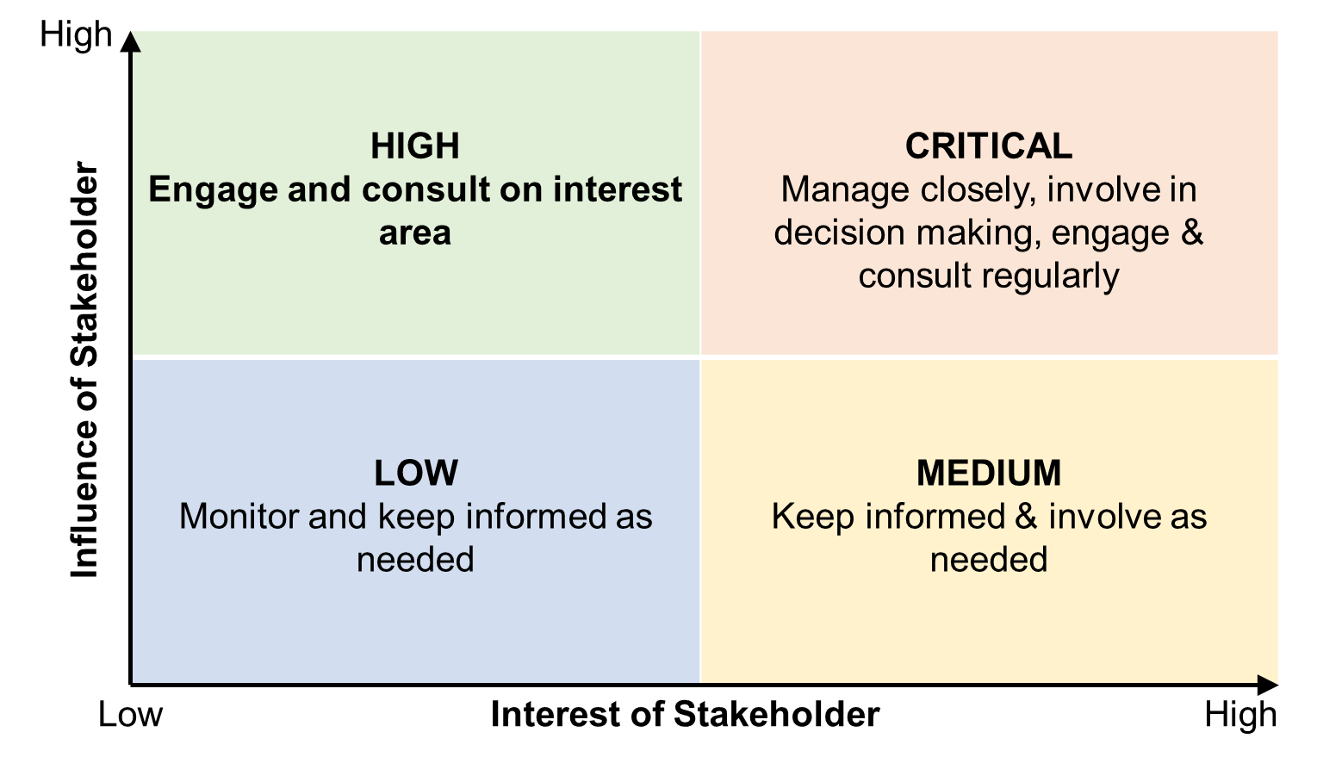

• Critical: High influence, highly interested people (Manage Closely)
• High: High influence, less interested people (Keep Satisfied)
• Medium: Low influence, highly interested people (Keep Informed)
• Low: Low influence, less interested people (Monitor)

Figure 2: Stakeholder influence – interest matrix
By classifying stakeholders in this way, one can determine cases where: 1) significant awareness-raising is required to turn a highly influential but low-interest stakeholder into an interested potential partner or 2) significant capacity development is required to turn a stakeholder with high interest but low influence into a stronger potential partner. This exercise helps to define your engagement strategy (see further).

Strategies for stakeholder engagement and uptake
After you have identified and analysed your stakeholders, it is important to come up with a plan for engaging all the major stakeholders throughout the project cycle, especially to invest in building relationship with stakeholders from the start. A well-developed stakeholder engagement strategy is critical for the success of the project in terms of potential impact, uptake, sustainability, efficiency, etc. Already having a good understanding of stakeholders, potential beneficiaries, end-users and/ or intermediaries helps projects create the conditions for uptake. It allows projects to identify actual needs, priorities, capacities, power relationships, etc. which can be taken into account when designing the project.

For example: If the project seeks to have an effect on policymakers, then the project needs to engage with local government during the whole duration of the project in order to raise interest and ensure that the project can actually have a significant impact. The project can consult policymakers throughout the process or could even involve them in decision-making.

In a stakeholder engagement strategy, you define what can be considered meaningful participation for which group of stakeholders, when and how you will build a relationship with them (before, during and after the project). Targeted and accessible communication, trust and mutual respect, early and regular interaction, building capacity of knowledge producers, users and intermediaries, impact oriented planning and monitoring are crucial mechanisms for successful stakeholder engagement and research uptake (For more information on these mechanisms see VLIR-UOS uptake brochure).
You will develop different approaches for the stakeholders who you consider as ‘critical’ (see stakeholder analysis - high interest and high influence) compared to those who are in the ‘low category’ for example. For some stakeholders, this can imply you foresee a limited number of information sessions throughout the project, for other (key) stakeholders it might mean you involve them in an advisory board that helps define the focus and implementation of the project and also follows up on results and how to use them. The questions to ask when developing an engagement strategy are:
- How will they be consulted / reached / approached / involved?
- How to secure their commitment / meaningful participation from the start?
- How will their interests be taken into account?
- How to counter, mitigate negative influence?

The level of engagement can vary along a continuum from limited participation to maximal participation as indicated in table 1.
Table 1: Examples of stakeholder engagement strategies
Engagement strategy | Monitor | Inform | Consult | Involve | Collaborate | Empower
Description of stakeholder participation | Pay attention to the actions of stakeholders | Researchers share information on research objective and results to help them understand the research (translated to non-academic audience) | Researchers obtain feedback on the research | Regular dialogue and advice,  researchers work directly with stakeholders to ensure that their concerns are considered in the research | Researchers acting together in a partnership with stakeholders for co-creation of aspects of the research (joint decision-making, control, implementation) | Researchers assist stakeholders in conducting their own research
Examples of engagement activities | Attending meetings, activities of stakeholders | Conference  Poster  Social media  Website  Webinar  Publication  Info sessions  Video  Policy briefs, radio talk shows | Survey  Focus group  Consultation meetings  Interviews  Baseline analysis to target trainings for users accordingly | Capacity building & awareness raising  activities, workshops, platform, network, forum, targeted dissemination activities, continuous needs assessment, training of intermediaries | Task force, working group, advisory board, committee, agreement, action plan | Community-based research, participatory research methods, participatory monitoring/planning
Source: Stakeholder engagement in research: The research-modified IAP2 spectrum – Integration and Implementation Insights (i2insights.org)
Uptake of results
Stakeholder engagement is key to enhancing the uptake of research results. Research uptake activities aim to support:
- The supply of highly relevant results through continuous engagement with stakeholders (including potential end-users). This involves communicating knowledge effectively and synthesising and repackaging knowledge for non-expert audiences.
Knowledge communication is not something done at the end of a project but needs to play an important role throughout the project (engaging stakeholders, raising interest, etc). Knowledge communication goes beyond one-directional ‘dissemination’ of research findings, it is a two-sided process. It is about engagement and knowledge exchange, brokering, etc.
- The usage of results by capacity building of both users as well as producers, and by increasing commitment of stakeholders.

A recent evaluation of VLIR-UOS projects has shown that the following preconditions (orange) and mechanisms (green) were conducive for the uptake of results. The document in the footnote develops this more in-depth (esp. as from page 18).
Precondition or mechanism
Understanding of the broader system/context, including structural barriers.
Understanding of stakeholders, potential beneficiaries and/or intermediaries.
Understanding of policy priorities.
Research is participatory, demand-driven and needs-oriented.
Collaboration exists between researchers and end-users.
Interaction between researchers and users is frequent and long-term and characterized by trust and
mutual respect.
Opportunities for direct contact between researchers and users exist.
Researcher has skills in in storytelling, networking, and translating research results.
Users’ have skills for evidence use and access.
Research products are targeted and accessible.
Intra-organisational linkages promote knowledge sharing beyond the organisation.

It is important to seek alignment to the different stakeholders’ needs, mutually agree on engagement strategies and jointly (re)defining desired social change processes. Engaging with stakeholders, right from the start of a project (or better yet: before the start) is crucial to create the conditions for uptake. Implementing a project and holding a one-off dissemination workshop at the end of a project is not sufficient. Especially, for vulnerable groups time is needed to create safe spaces and adapt processes to include their voices and avoid unequal power relationships. Stakeholder engagement is ideally a continuous and active process, especially since interests and coalitions can change throughout the time. It is thus important to also follow up on your engagement strategy closely during project development, being in annual reporting and planning, as highlighted in the following figure.

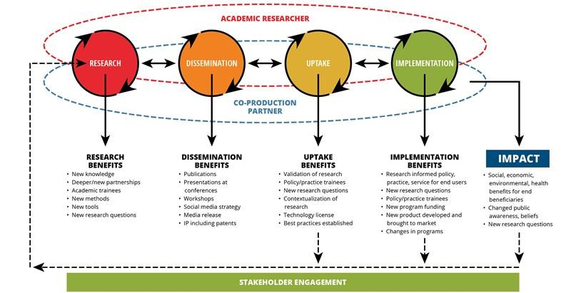
Figure 3: Impact Framework – Kids Brain Health Network – Réseau pour la santé du cerveau des enfants
Coherence
External coherence
External coherence refers to the complementarity and/or synergy with initiatives taken in the same domain / context by other organisations (local, regional, Belgian actors, etc.). In the proposal, the match / link with other externally funded projects and actors from Belgian development actors already active in the targeted country should be described, including how they plan to engage with the other organisation.

For more information check the VLIR-UOS country reference frameworks on the VLIR-UOS website with more details on the geographical and thematic Joint Strategic Frameworks of Belgian Development Cooperation. The Belgian geographical and thematic Joint Strategic Frameworks (JSFs) provide information on “who is doing what, where” and contact details of different organisations. It is expected that projects identify the opportunities for synergy and complementarity with Belgian development actors in the region and engage with them (where relevant, possible).

Internal coherence
Internal coherence refers to the synergy and/or complementarity with other VLIR-UOS funded activities, for example how the project matches with other ITP, TEAM/SI, IUC, Global Minds, ICP projects, etc. working in the same region or on the same topic (potential collaborations with other VLIR-UOS projects are important here, previous experience between the projects partners fits under lessons learned in Module 8).

Checklist to integrate the SDG principles in Module 4
Leaving No One  Behind | - Does your stakeholder analysis include the perspectives of those (at risk of being) left behind?  - Are left behind groups that might be affected by the intervention involved in planning & implementation in an active and meaningful way?  - Does your project consider representation and participation of women and disadvantaged groups in the identification and selection of project counterparts and/or advisors (e.g., women’s groups, associations of persons with disability)?
Interconnectedness & indivisibility | - Was your stakeholder analysis co-created by the relevant (local) actors, including marginalised groups?
Multi-institutional (MIPs) and multi-stakeholder partnerships (MSPs) | - Have you analysed which actors can support or contribute, and which actors might present obstacles or risks, taking into account interest and power or influence?  - Are local actors (beyond institutional actors and including marginalised groups) involved in an active and meaningful way when relevant?  - Are partners involved in monitoring, evaluation and learning when relevant, including local actors and vulnerable groups?

Module 5: Planning & budgeting
ESSENCE
This aspect focusses on how the project will contribute to the set goals in the six project domains. It specifies what activities must be done to achieve a particular goal (or goals), when they need to be done and who is going to do them. It does not only include the outputs that need to be delivered, but also the financial & human resources attached to it.
KEY QUESTIONS
- What activities per project domain do we need to implement to deliver the results?
- When do we need to implement them?
- What means? Who is responsible?
- What management activities are needed to guarantee a smooth implementation?
- Value for money: elaborate a narrative on your budget. Motivate the requested total amount. Elaborate on how much will be spent on the different activities and why you choose this repartition.

Checklist to integrate the SDG principles in Module 5
Leaving No One  Behind | - Is the planning of activities informed by the context analysis with attention for left behind groups?  - Are (far) left behind groups that might be affected by the intervention involved in planning & implementation in an active and meaningful way?  - Does the project ensure gender balanced participation in project activities? (e.g., providing day care during training)  - Is sufficient budget foreseen for gender mainstreaming activities?
Interconnectedness & indivisibility | - Have you taken important (positive and negative) links into account in the planning & implementation of your theory of change (e.g., in objectives / activities)?
Multi-institutional (MIPs) and multistakeholder partnerships (MSPs) | - Have the different partners reflected on whether the MIPs and/or MSP adds value (do the benefits exceed the costs)?

Module 6: Risks
ESSENCE
Identify and manage the key risks the project will potentially face
KEY QUESTIONS
- What are the key uncertainties, assumptions risks (based on Module 2)?
- What is the probability the risk will occur?
- What is the potential impact of the risk?
- How can we reduce the potential impact of the risk or reduce the probability of the risk occurring?
- Who is responsible for follow-up / risk monitoring?

Applicable only for TEAM-Fully fledged and IUC proposals.
This part is however relevant for all project types in order to follow-up and report once the project is being implemented.

Module 7: Monitoring & reporting
ESSENCE
This aspect focusses on the performance and measures the progress towards realising the goals of the project. This is done on the basis of the planning (see Module 5.) and by collecting the relevant data and analysing indicators at the level of the project. It is relevant for accountability (reporting), but also for learning and steering purposes (see Module 8).
KEY QUESTIONS
- What information do we need to track and analyse the change process as it evolves?
- What information do we need to monitor assumptions or learn about the change process?
- What information do we need to demonstrate the realisations of the project?
- How will we collect this information? Who will do this? When? What systems need to be put in place?

Applicable only for TEAM-Fully fledged and IUC proposals.
For ITP proposals, this module is not applicable except the elaboration of the approach the project has towards monitoring and evaluation.
This part is however relevant for all project types to follow-up and report once the project is being implemented.
All VLIR-UOS projects will be required during execution to report/follow-up on a short list of standard indicators per project domain (education programmes and methods; research programmes and methods; outreach and policy support; networks and partnership; systems, policies and infrastructure).
Only the standard indicators in the domains addressed by the project need to be tracked in annual reporting. Disaggregation by sex and stakeholder type for certain indicators is also required for some indicators. In the light of LNOB, some indicators on disability and minority groups are added to analyse the project results from an inclusion perspective.
An indicator provides a marker of whether a certain change has happened or whether certain conditions exist. Indicators can be quantitative or qualitative, direct or indirect.
In addition to standard indicators, project-specific indicators (max. 2) can be put forward by the project to measure progress towards the achievement of their results and to steer decision making by the project management. Development and selection of these specific indicators should be guided by commonly used criteria to assess the quality of an indicator, such as the SMART (Specific, Measurable, Attainable, Realistic and Timebound) or SPICED principles (Subjective, Participatory, Interpreted, Cross-checked/Comparable, Empowering, and Diverse/Disaggregated).

Use & reporting of indicators
Projects have to report on annual basis the progress made in standard indicators and, if applicable, project-specific indicators. During formulation, the baseline and target values should be provided in the excel sheet. VLIR-UOS asks projects to correctly copy the standard (as to allow future aggregation) and not to alter the formulation (adding information to the formulation is possible. This data will be aggregated at VLIR-UOS level to monitor progress and impact of all VLIR-UOS projects. The project-specific (own developed) indicators do not need to be followed-up by VLIR-UOS in annual reporting. This is the responsibility and own decision of the project.
For ITP there are no baseline nor targets to fill in during the formulation or the start of the project.
Failing to plan is planning to fail
Projects need to plan the measuring of indicators and need to take into account the feasibility (cost/benefit) of measuring indicators. For all the project types, except for ITP, there is a column “Source of Verification” (where will the project get the information) in the results framework module. Next to identifying the source of verification, projects need to think about:
- How will we measure the indicator?
- Frequency of data collection: annually, during reporting
- Who in the team is responsible for the data collection?

Checklist to integrate the SDG principles in Module 7
Leaving No One  Behind | - Does the M&E system provide sufficient information about change at the level of the target groups and the (in)direct contribution of the project towards those changes?  - Does the project require disaggregated indicators for follow-up?  - Are relevant gender-specific indicators and/or indicators that are disaggregated by sex selected?  - SMART or SPICED use/collection of specific indicators?
Interconnectedness & indivisibility | - Have you taken important (positive and negative) links into account in the design and implementation of your indicators?
Multi-institutional (MIPs) and multi-stakeholder partnerships (MSPs) | - Have relevant stakeholders been involved in the identification of the indicators that most meaningfully indicate anticipated (intermediate) change?  - Is another entity or actor already collecting the data we need? Do we have access to that information, can we use it?

Module 8: Learning & steering
ESSENCE
This aspect involves following-up on changes, adaptations and lessons learned in order to improve the quality of the project.
KEY QUESTIONS
- During project formulation: How will the recommendations of the selection commission / lessons learned from previous experiences be taken on board? What will you do differently?
- What have we learned from previous projects, in particular in the case of follow-up projects? In the case of follow-up projects, what is the added value of this project?
- During project implementation: How do you plan to systematically follow-up on your theory of change / identify good practices / learn (e.g., peer-to-peer between similar VLIR-UOS projects, sharing lessons learned in progress reports)?

Formulating lessons learned and learning from experience
VLIR-UOS wants to stimulate peer-to-peer learning between projects and exchange good practices with the community. This will be further developed and implemented in the future, for example through platform activities aiming at collective learning or storage of key lessons learned in a database / website.
The following questions can help to capture interesting lessons learned, good practices and steer projects in the right direction (at formulation stage, during and after implementation) to have greater results:
- What were the main success factors? What worked well?
- What is useful to share with others? What recommendations do you have for other similar projects?
- What went wrong, what were the key problem areas, what did not turn out as expected and why?
- How did the project overcome certain difficulties?
- What needs improvement / at what level (VLIR-UOS, institution, project team, technical, etc.)?
- How can this be improved in the future?
- If you would do the project again, what would you do differently?

Checklist to integrate the SDG principles in Module 8
Leaving No One  Behind | - Are there explicit mechanisms for participation of the target groups in the project M&E system?  - Does the project M&E system include systematic reflections on the implications of the intervention for any vulnerable groups who (according to the ToC) may benefit indirectly? (e.g., through existing secondary data sources without you having to collect data on groups that are not direct target groups)  - Does the project M&E system include systematic reflections about potential negative effects for vulnerable groups (e.g., as identified through risk analysis)? And if any negative effects are observed, does this inform remedial action?
Interconnectedness & indivisibility | - Have you reflected on the extent to which the intervention maximized pre-identified co-benefits and mitigated pre-identified trade-offs? Was a good balance struck?  - Have you reflected on unforeseen co-benefits and trade-offs, or limiting and enforcing links?  - Does your M&E system provide sufficient space for learning about important interlinkages (co-benefits and trade-offs)?
Multi-institutional (MIPs) and multistakeholder partnerships (MSPs) | - Have you adjusted partnerships based on lessons learned?  - Have the different partners reflected on whether the positive impact of the MSP can be improved (e.g., via new partners, other collaboration forms, contribution of the partnership to specific outcomes)?

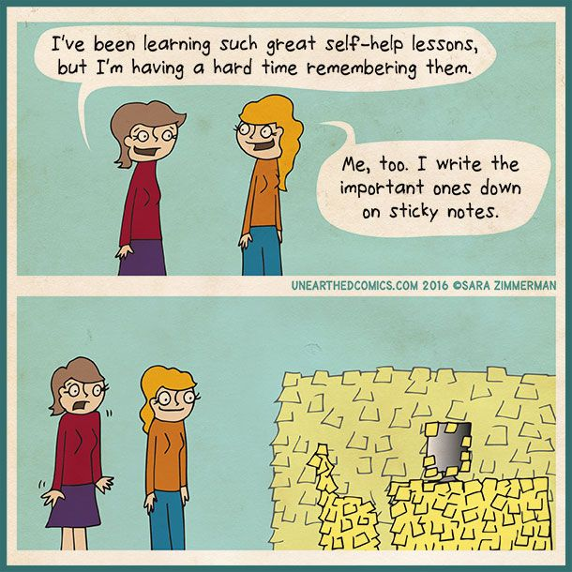

Annex 1: Additional tools for inspiration
SDG-principles
- LNOB good practices and thematic working aids (Guide de l’Agence Suisse de Coopération)
- SDG as a compass for Belgian Development cooperation (HIVA & IOB)
- LNOB indices of countries (Overseas Development Initiative)
Transversal themes
- Gender mainstreaming the project cycle (UNIDO)
- This toolkit clearly explains and provides guidance on how to integrate gender in research. A useful checklist is given Toolkit – Gender in EU-funded research
- Inspiration guide on how to integrate gender sensitiveness in non-governmental cooperation (NL/FR)
- Manuals with guidelines on the integration of sex and gender analysis into research contents, recommendations for curricula development and indicators
- Guidelines Gender-Sensitive Teaching: An introduction for teaching staff in STEM
- KLIMOS Environmental Sustainability Toolkit
- Louvain Développement Environmental Integration Tool (EIT)
- The Educaid.be methodological sheet
Module 1: Context
- Rich picture
- 5 Why’s?
- SWOT analysis
Module 2: Project Strategy
- Rich Picture
- Three spheres model (p. 106)
- Theory of Change – Development Impact and You (diytoolkit.org)
Module 3: Organisation
- Project organogram / project organisation chart
- Five types of organizational structures
Module 4: Stakeholders and coherence
- Seven principles for effective multi-stakeholder partnerships
- The Partnership Initiative Guidebook
- https://mspguide.org/msp-tools/
- VLIR-UOS Uptake brochure
Module 6: Risks
- Risk matrix
Module 7: Monitoring & reporting
- List of standard and optional indicators in APR (c. website)
- Equal Access Participatory M&E toolkit - Module 2 (setting objectives & indicators)

This guide mainly draws from the European Commission’s Project Cycle Management guidelines, HIVOS Theory of Change handbook and the SDG Compass guide.
The modules are inspired on the PRINCE2 methodology and themes for project management.
Adapted from the SDG Proofing Toolkit (2021) developed for Belgian Development Cooperation.
THE 17 GOALS | Sustainable Development (un.org) SDGs as a compass for Belgian development cooperation: Capacity building package – HIVA (kuleuven.be)
Country reference frameworks were elaborated for the 17 countries + Belgium in the VLIR-UOS project partner country list. (see links at the end of this document)
Environmental sustainability refers to the capacity of the environment to maintain its key functions and processes on the long run. It means not taking from the Earth more than what it’s giving. Source: the Environmental Integration Tool (EIT) by Louvain Coopération
https://sdgs.un.org/goals
Fit with selection criterion 2 on the Quality of the design of the proposal (descriptor 2.1.)
We define uptake as ‘the use of research and education results of HEI by non-academic actors (or society at large: policymakers, NGOs, private sector, farmers)’ and creating the conditions for uptake as ‘all activities that facilitate and contribute to the use of research evidence or other results emanating from the work of Higher Education Institutions (HEI) by policymakers, practitioners and other development actors’. (See Uptake Brochure here)
Source: Stakeholder Characteristics and Roles Matrix | Multi-Stakeholder Partnerships (mspguide.org)
For more information on uptake, please consult our recently published brochure here.
See also Project Objectives, Indicators and Assessing Social Change (betterevaluation.org)
The SPICED approach puts more emphasis on developing indicators that stakeholders can define and use for their own purposes of interpreting and learning about change, rather than simply measuring or attempting to demonstrate impact to meet donor requirements.

